[Template]

Project Design Document

1. Design Intent
- What experience are you trying to create?
To create an exciting and playful mini bowling experience that combines physical interaction with digital feedback. The aim was to make users feel engaged through lights, score tracking, motion, and game-like responses in a compact tabletop format.
- Who is it for?
Designed for students, casual users, exhibition visitors, and anyone looking for a fun interactive activity. It is especially suitable for educational showcases where physical prototyping and electronics are demonstrated.
- If solving a problem, what problem does it solve?
The project solves the issue of making bowling accessible in a smaller, low-cost, portable format while still maintaining the excitement of the real game. It also demonstrates how electronics can enhance traditional physical games

2. Inspiration & References
- Existing products / ideas
Real-life bowling alleys and arcade bowling games
Interactive toy systems with scoreboards and lights
Mini tabletop game concepts
OLED-based gaming interfaces
LED-lit arcade aesthetics

- Images / links
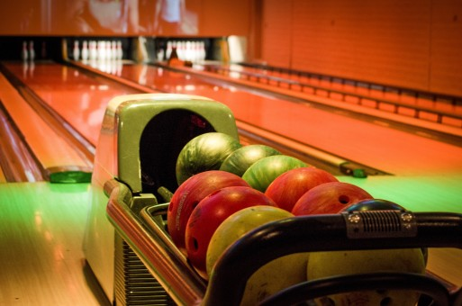

https://activitykidz.com/collections/bowling-alleys-in-delhi-ncr?srsltid=AfmBOooC6LB75mLVvreHbdHSFOWZFOlyzu_Xb6cCO3BOc-8bReTSvQVb
https://torq03.com/top-reasons-torq03-is-the-best-bowling-alley-in-bangalore-for-fun-and-competition/
- What did you learn from them?
User engagement increases with instant visual feedback
Compact games need simplified mechanics
Lighting and branding improve attraction value
Clear score systems make gameplay intuitive

3. User Journey
Step-by-step experience of the user:
- User approaches the Bowling Star setup.
- OLED screen displays “SCORE : 0” message.
- User rolls the bowling ball toward the pins.
- Pins fall and system detects the number knocked down.
- If pin falls to gutter, the screen shows “GUTTER!”
- OLED updates score instantly.
- LEDs respond with celebratory lighting effects of pin fallen.
- final score is displayed.
- System resets using a button for the next player.
👉 Think like storytelling

4. Success Criteria
Define measurable success:
Functional :
Score updates within 1 second of pin detection
OLED display remains clear and readable
LEDs respond correctly to gameplay states
Structure remains stable during play
User Experience :
Easy to understand without instructions
Enjoyable and visually attractive
Quick reset for repeated play
Reliability :
Sensors detect pins accurately
Mechanism works consistently over multiple rounds
Electronics remain safely connected

5. System Overview
- Bowling Star is an interactive bowling setup consisting of a bowling lane, physical pins, a bowling ball, detection sensors, microcontroller logic, OLED screen, LED strip, and optional servo mechanism for movement/reset.
Main Parts:
Bowling lane structure
3D printed bowling pins
Bowling ball
ESP32 / microcontroller
OLED display
IR / button pin detection system
LED strip
Power supply
Pushbutton

6. High-Level Block Diagram
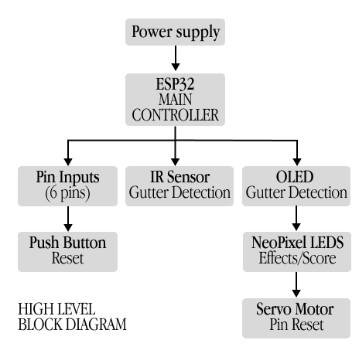

7. Input / Output Mapping
Input | Process | Output
Ball hits pins | Sensors detect fallen pins | Score increases
Start power | System initializes | Score Shown as 0
Push Button | Reset command | New game starts
IR triggered | IR sends signal | “GUTTER” displayed

8. Sketches & Concepts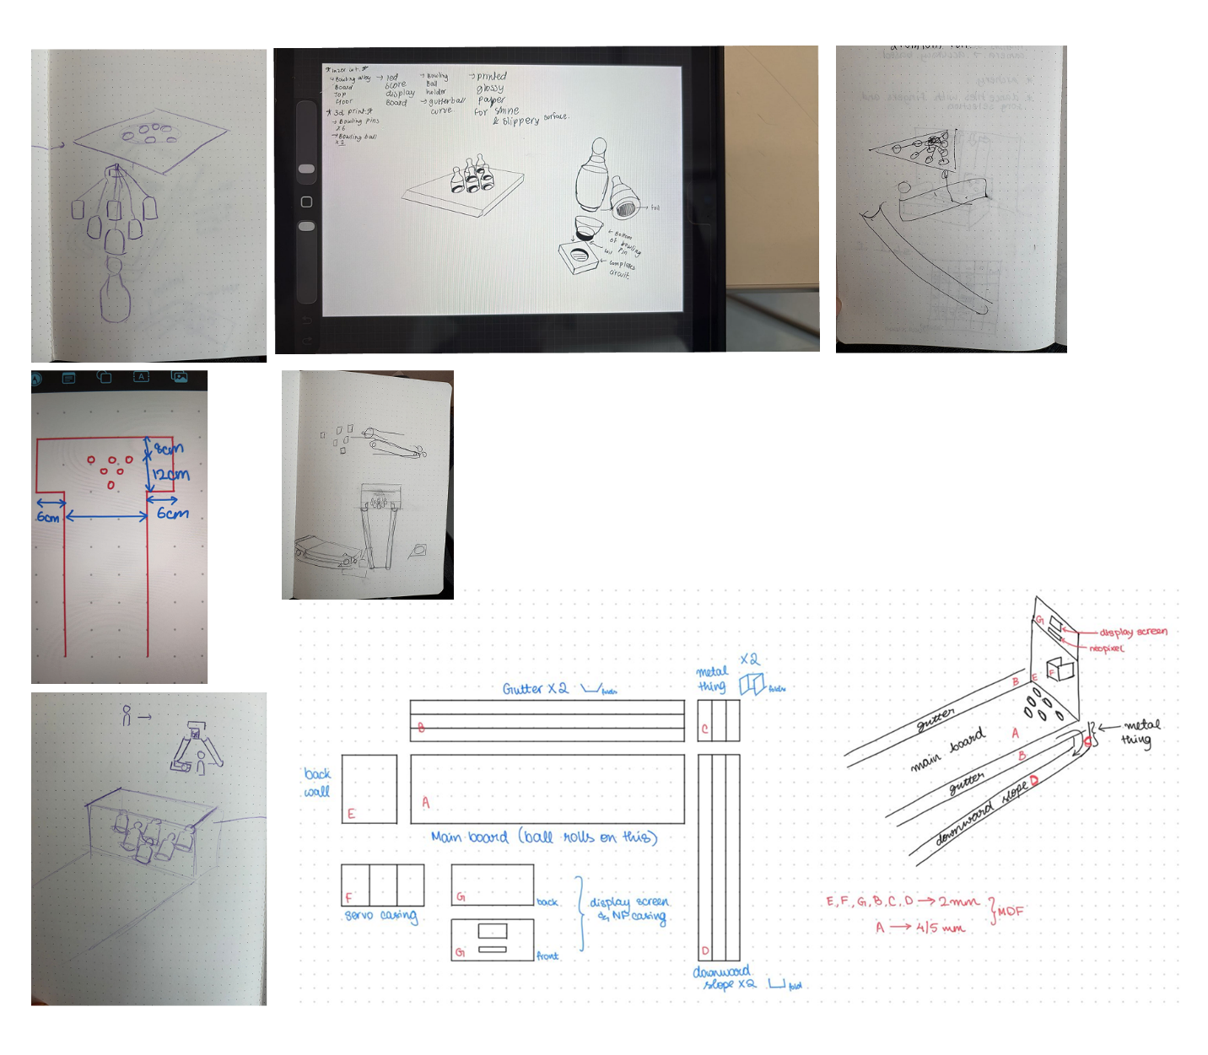

9. Final System Architecture (Labelled)
👉 Clear diagram showing all components and connections
